Vloom Forge
Detailed instructions on how to prepare a topic
Part I: Instructions for preparing questions
Step 1: Prepare the original file content
Delete the content of the beginning and end of the exam, you only keep the content
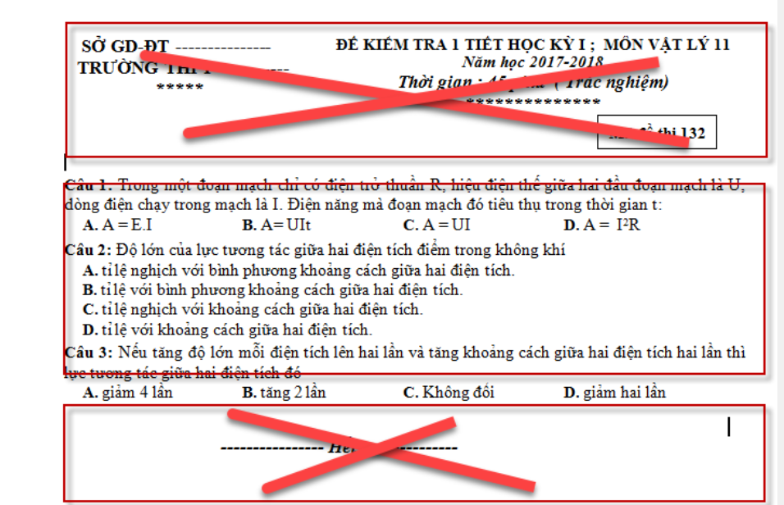

Step 2: Prepare the original exam content
- The questions must start with Câu {number}: or Question {number}: followed by the question in English.
- The answer section must not be on the same line or contain the same content as the question; before starting the answer section, you must press Enter to move to a new line.
- The answers must start with A., B., C., D., and these characters must be in bold.
- Each answer is recommended to be placed on a separate line.
- If an answer is correct, it should be marked in bold and red, e.g., A
- If the question and answers include images, they should be set to Inline with text mode (so that when rearranging, the images won’t shift unpredictably).
- If your question has no answers or no correct answer, it will not be converted into Moodle XML.
- For True/False questions, each idea should begin with a), b), c), or d), and should be bolded for better visibility. If any answer is True, highlight it in red.
- Note that if a multiple-choice question with a single answer contains a) b) c) d) in the question text, you should replace them with different characters.
For example,
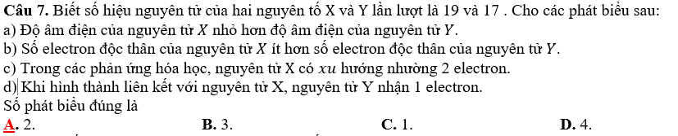
It is recommended to replace a), b), c), d) with other characters such as I, II, III, IV, as shown in the example below.
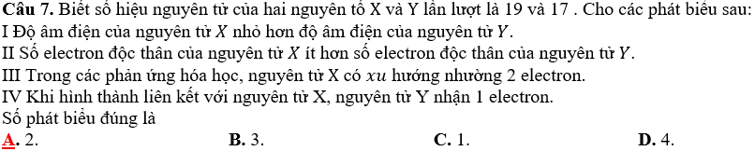
- To be able to convert True/False type questions, you need to download and use the Matrix question type:
https://moodle.org/plugins/qtype_matrix/versions
Choose the version that matches your Moodle installation.
- For Short Answer questions, after the question statement comes the answer section, labeled as:
A. Answer
- Vloom Forge supports the Cloze embedded question type, allowing you to include both the content and the questions within a pair of <group></group> tags. Each question must also be ended with a <br> tag.

For Example: (including feedback for the Cloze embedded question type)
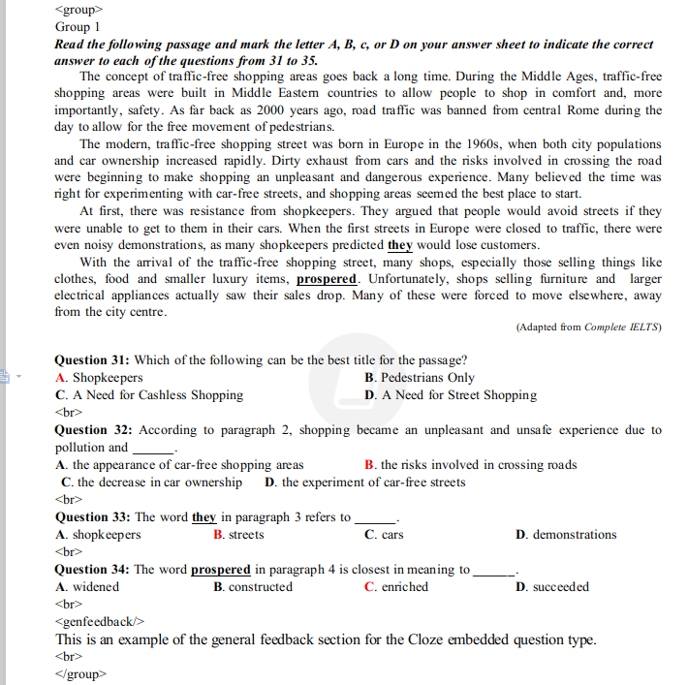
- Vloom Forge supports using the General feedback feature in Moodle.
There are two ways to write General feedback for each question in Moodle
Place it after the question and answer, beginning with <genfeedback/> and ending with <br>.
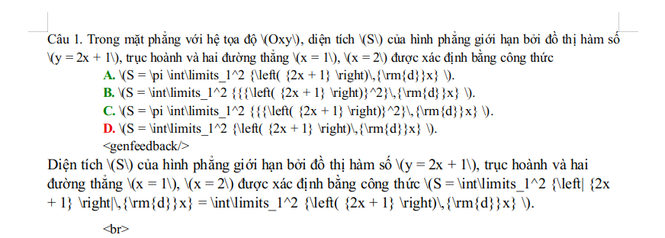
- For Cloze embedded question types, write the general feedback inside the <group></group> tags.

For example :

Part II: Common Errors
Error 1: Question or answers placed inside a table
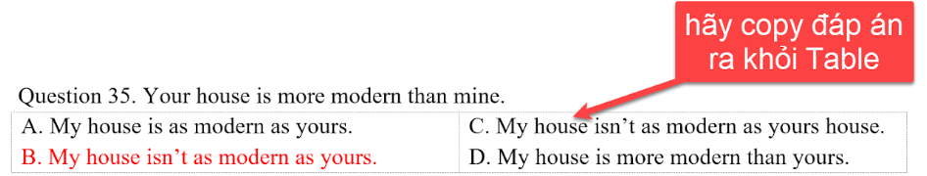
You should copy all content question or answer out of the table

Error 2: Typing mistake or missing the required keyword at the beginning of the question
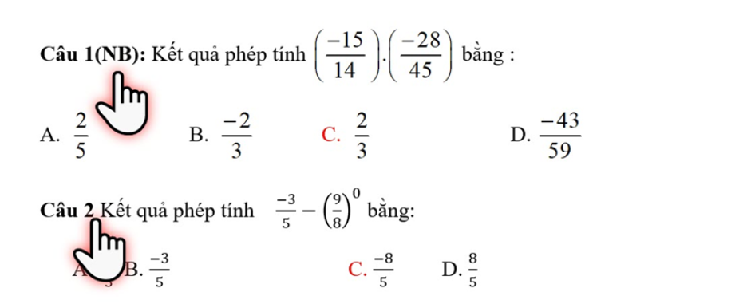
This error occurs because you haven’t prepared the questions according to our instructions.

Error 3: Typing mistake or missing the required keyword at the beginning of the answer
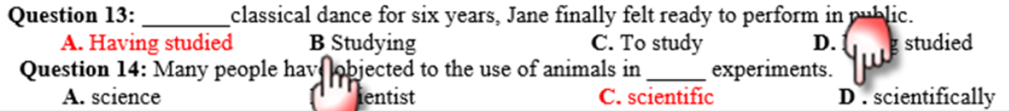
Question 13: Please add a period (.) after the character B
Question 14: Please remove the space between the character D and the period (.)

Error 4: No line break between the question and the answer section
You need to press Enter before starting the answer section so that we can distinguish between the question and the answers.

Error 5: No line break between the answers of the previous question and the next question.
This error prevents us from recognizing the question. It is very hard to detect. In MS Word, it may appear that there is a line break (Figure 1), but actually there isn’t. When uploading the questions to Vloom Forge for shuffling, it causes questions to stick together as shown in Figure 2.
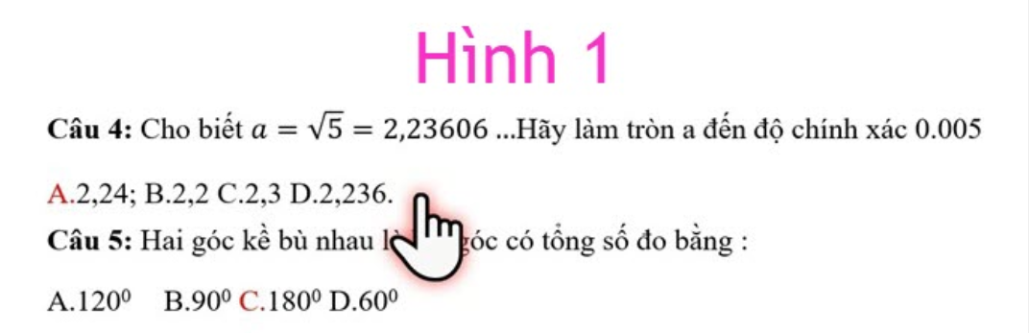
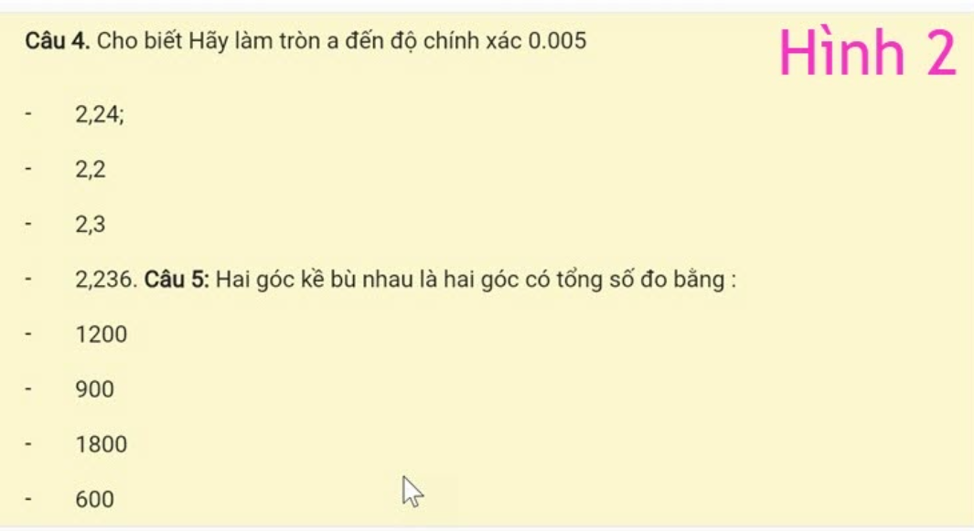

Error 6: Answers use the Numbering feature in MS Word
Answers are often automatically numbered, e.g., A., using MS Word’s Numbering feature. This makes it very difficult for us to recognize the answers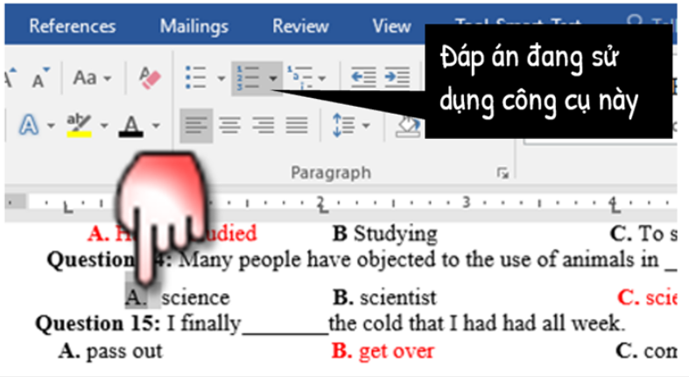
You should delete this letter and rewrite it

Error 7: Vloom Forge mistakenly recognizes answer keywords from units, quantities, proper names, place names, or any answers containing the characters A, B, C, D.
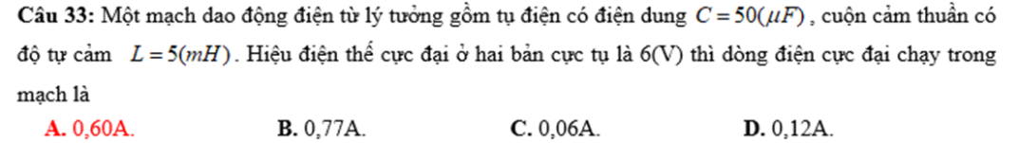
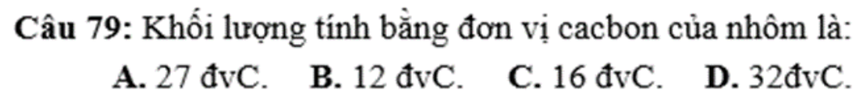
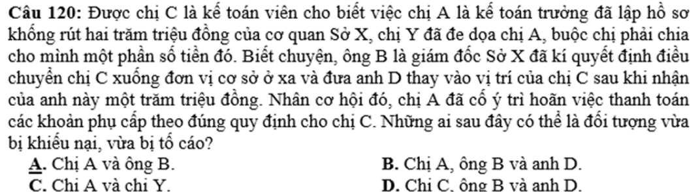
In this image, proper names in the Civic Education subject may be mistakenly recognized as answers.

In the cases above, please:
- Place each answer on a separate line,
- Or do not bold the units in physics,
- Or remove the period (.) immediately following the unit.

Note : If, after conversion, some sections do not appear as intended, please try adjusting them directly in your word file.

